G2 Doors
Goff’s G-2 Doors feature easily replaceable, exchangeable heat sealed panels available in vinyl, mesh, and clear PVC giving you the ability to replace or exchange sections of the door with the changing seasons without down time or destruction to the door. Also featuring a wind load rating of 45 mph on a 10’x12’ door, G-2 Doors automatically reset after impact or blow out. Goff’s uniquely created fiberglass extrusions slide securely in custom extruded aluminum side beams in a variety of manual and motorized operations including: chain hoist, 12” per second, 28” per second, and 36” per second. Other features include: a reverse safety feature, welded seams, and EPDM rubber side seals & baffle. With a design that excludes wheels, cables, springs and sewing the G2 Door is “Simply. Intelligent.”

Visit www.cisco-eagle.com for more information, or call 888-877-3861

Benefits of Goff's G-2 Mesh Doors Include:
• Significantly reduces heat from sun while allowing light and fresh air into work areas.
• Keeps out unwanted pests, birds and intruders.
• Controls airborne contaminants.
• Improves building appearance.
• Increases security, deters trespassing, theft and vandalism.
• Allows fresh air to flow through for comfort and productivity
• Helps meet FDA and AIB requirements.
• Exchangeable panels allow the same exterior door to be used in both warm & cold weather situations. Allow air to flow through in summer and keep heat in during cooler months.

Benefits of Goff's G-2 Vinyl Doors Include:
• Saves energy and time by opening and closing the door’s opening up to 12 times faster than a traditional sectional overhead door.
• Allows the same exterior door to be used in both warm & cold weather situations. Allow air to flow through in summer and keep heat in during cooler months.
• Significantly reduces heat loss while allowing light into work areas.
• Keeps out unwanted pests, birds and intruders.
• Controls airborne contaminants.
• Improves building appearance.
• Increases security, deters trespassing, theft and vandalism.

Features of Goff's G-2 Doors Include:
• Automatic re-set after blow-out
• Reflective photo eye safety feature included (motorized only)
• Wind load ratings by door size
• Easily replaceable, exchangeable heat sealed panels available in solid vinyl, mesh, & clear PVC.
• 11 oz Mesh optional panels that are constructed of 17 X 11 polyester scrim, providing small openings difficult for insects to penetrate & provides a 65% shade factor to lower temperature and save energy, while meeting AIB standards.
• 18 oz coated colored Vinyl
• 40 Mil double polished clear PVC
• Resistance to all ultraviolet rays and is rot, tear and mildew resistant.
• Meeting NFPA 701 and California Fire marshal standards for flame resistance.
• Three year warranty on materials & workmanship – One year warranty on motor drive mechanism.

Sizes & Colors
Goff's G-2 Doors are available in sizes up to 16' x 16' h. 9 Vinyl Color Options and 7 Mesh Color Options Available!

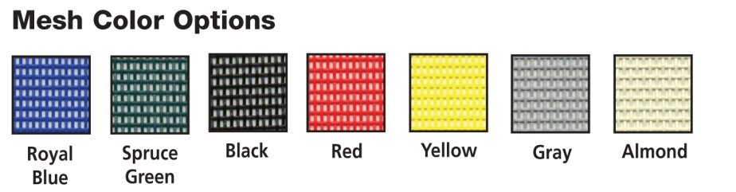
Beige -18 oz
Black -18 oz
Blue -18 oz
Green -18 oz
Grey -18 oz
Orange -18 oz
Red -18 oz
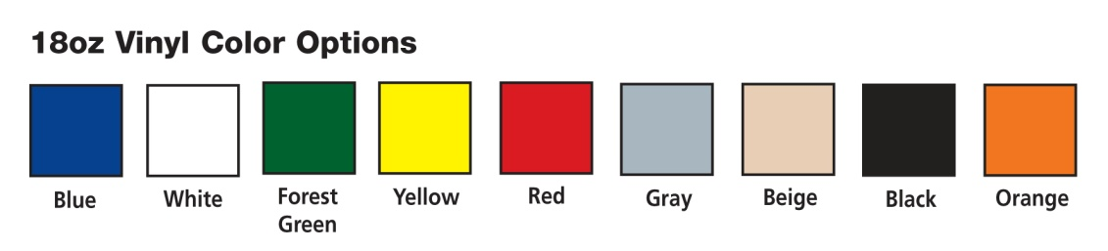
White -18 oz
Yellow -18 oz
Almond -11 oz Mesh
Black -11 oz Mesh
Blue -11 oz Mesh
Green -11 oz Mesh
Grey -11 oz Mesh
Red - 11 oz Mesh
Yellow - 11 oz Mesh

Vinyl and Mesh Door Warranty

3-year limited warranty on materials and workmanship. Warranty excludes electric motor and spring-assist roll-up mechanism; warranty on these items is 1 year. Goff's reserves the right to repair or replace warranty items at its discretion.

Options & Accessories:
Auto Close Timer - Automatically Open & Close the door after a selected time.
* Only Available on the 28" and 36" per second motors.
External Motor Cover Motor Cover is designed indoor & outdoor use with 36" per second motors.
Extra Window Add an Additional 19" Window to Allow Extra Light In. *Standard on HarshGuard Doors.
Hand Held Remote Operate the door from a hand held remote control. Perfect for use with forklifts/vehicle traffic.
Motion Detector* The Motion Detector is not available for 6" per second doors.
Nema 1 Control The Nema 1 Control is Hardwired and Designed for Interior Use.
Nema 4 Control (Wired)The Nema 4 Control (Wired) is Hardwired and Designed for Exterior Use.
Also available with Locking Option!
Nema 4 Control (Wireless) Nema 4 Control (Wireless) is Designed for Indoor & Outdoor Use!
Pull Cord The Pull Cord can be used Indoors & Outdoors!
Single Button Control Operate the door with a single push of a button with this economical option.

